Data Flow Diagram

Date | 03-07-2026
Team ID
Project Name | Smart Agricultural Production Optimization Engine
Maximum Marks | 2 Marks

Data Flow Diagram
Create a Data Flow Diagram (DFD) to show how data moves through your system - between external entities, processes, and data stores. Use the symbol legend below as a guide.



DFD Symbol Legend

Symbol | Name | Description
Oval / Rounded shape | External Entity | A person, organization, or system outside the project that sends or receives data (e.g., Customer, Payment Gateway).
Rectangle with numbered header | Process | An activity that transforms incoming data into outgoing data (e.g., Validate Request, Process Order).
Rectangle (solid fill, no number) | Data Store | A place where data is held for later use (e.g., Customer Database, Inventory).
Labeled arrow | Data Flow | The movement of data between entities, processes, and data stores, labeled with what data is being passed.

Example
The diagram below illustrates how the symbols above come together to form a complete data flow diagram.
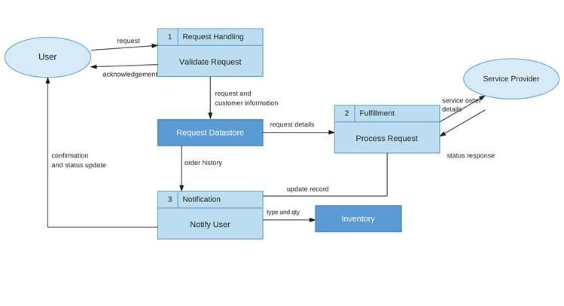

Level 0 Data Flow Diagram
Project: Smart Agricultural Production Optimization Engine

Main Process:
1.0 OptiCrop Engine - Farmers ki suitable crop suggest chese system

External Entities:
1. Farmer - Location and soil details input chestadu
2. Weather API - Rainfall and temperature data provide chestundi
3. Govt Agriculture DB - Soil type and market price data provide chestundi

Data Stores:
1. D1: Farmer Profile Database - Farmer details store avtai
2. D2: ML Model Database - AI prediction model store avthundi

Data Flows:
1. Farmer → 1.0 OptiCrop Engine : Location + Soil Type
2. Weather API → 1.0 OptiCrop Engine : Weather Data
3. Govt Agri DB → 1.0 OptiCrop Engine : Soil & Price Data
4. 1.0 OptiCrop Engine → Farmer : Crop Suggestion + Fertilizer Plan
5. 1.0 OptiCrop Engine → D1 : Save Farmer Data
6. D2 → 1.0 OptiCrop Engine : Prediction Result
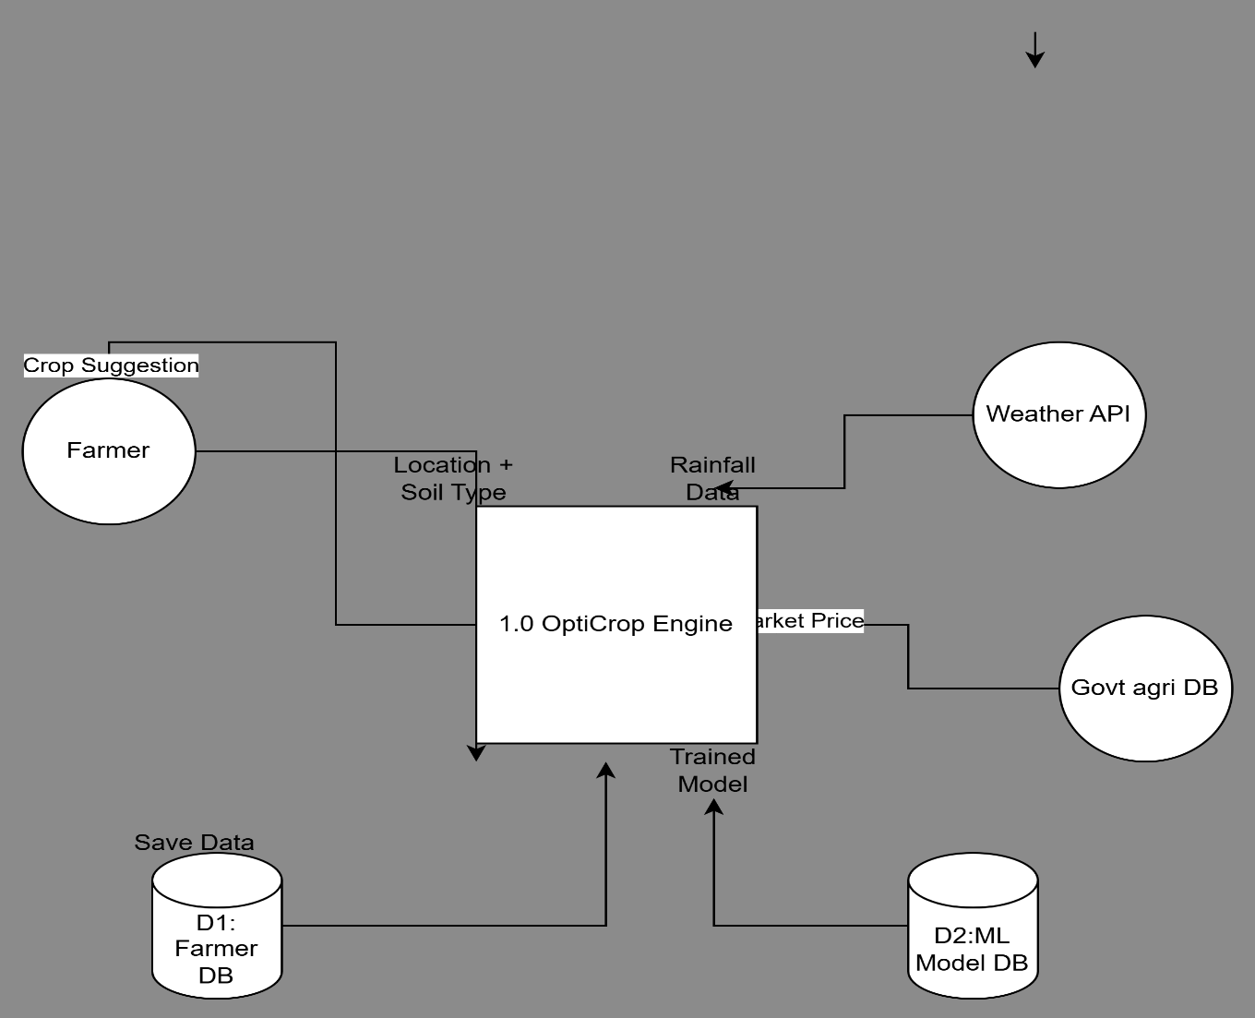

Figure1: Level 0 DFD for Smart Agricultural Production Optimization Engine

